
Bahria University, Lahore Campus
Department of Computer Sciences
AI Project
(Fall 2025)

Course: | Artificial Intellegence
Faculty’s Name: | Iram Noreen | Lab Teacher: Usman Anwar

Member of Project:

Hassan Irfan (036)
Ahmed Ali (013)
Mamoon Akhter (048)

Project Title: Sales & Customer Behaviour Insights

Abstract:
Understanding customer behavior is crucial for businesses to make informed decisions and improve sales strategies. In this project, we analyzed customer data to uncover patterns in demographics, loyalty tiers, and regional sales. Using Machine Learning, we combined clustering and neural network techniques to segment customers, producing clear insights that can guide marketing and business planning. The report includes accuracy plots and charts that illustrate the findings.
Introduction:
The Sales & Customer Behaviour Insights project is designed to help companies understand their customers and sales patterns more effectively. It uses AI to group customers based on categories such as Bronze, Silver, and Gold, making it easy to identify high-value customers. The system analyzes key data points like customer location, gender, and loyalty status to generate clear and practical insights. By organizing raw data into meaningful segments and visualizations, it supports informed business decisions and better resource allocation.
Literature Review:
Many studies emphasize the importance of customer segmentation in improving business outcomes. Techniques like KMeans clustering help group customers based on similar characteristics, while neural networks can classify customers into segments. These methods have proven effective in marketing analytics, allowing companies to tailor strategies for different customer groups.

Methodology:
- Data Preparation:
  - We removed missing values from key columns like gender, region, and loyalty tier.
  - Text data was cleaned for consistent formatting.
  - Signup dates were converted to a standard date format for analysis.
- Encoding Categorical Data:
  - We transformed non-numeric data such as gender, region, and loyalty tier into numeric values using LabelEncoder.
- Customer Segmentation (KMeans):
  - Data features were standardized using StandardScaler.
  - Loyalty tier was given higher weight to ensure important segments were distinct.
  - KMeans clustering created five customer segments.
  - Each segment was labeled based on the most common loyalty tier within it.
- Neural Network Model:
  - A sequential neural network with two hidden layers was implemented using TensorFlow.
  - The network was trained to classify customers into segments, using class weights to handle imbalanced data.
  - The model was trained on 80% of the data and tested on the remaining 20%.
- Visualization:
  - We created a plot showing model accuracy over training epochs.
  - Additional charts were generated to illustrate regional sales, gender distribution, customer regions, and loyalty tiers.

Results:
- Model Accuracy Plot
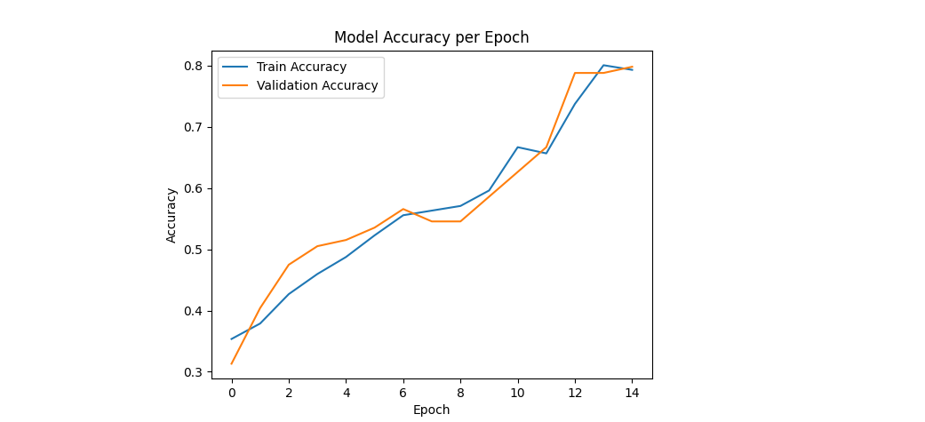
Figure 1: Training and Validation Accuracy per Epoch.
This chart shows the model’s learning progress over time and how accurately it classified customer segments.
- Regional Sales Distribution
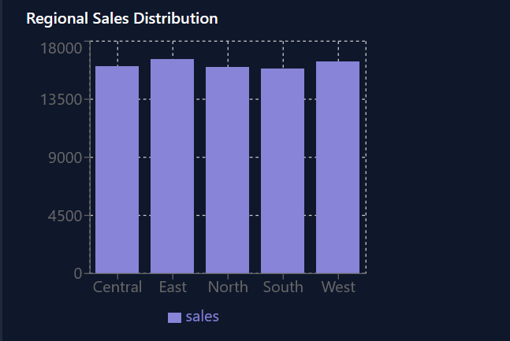Figure 2: Regional Sales Distribution.
Highlights which regions contributed most to overall sales.
- Customer Gender Distribution
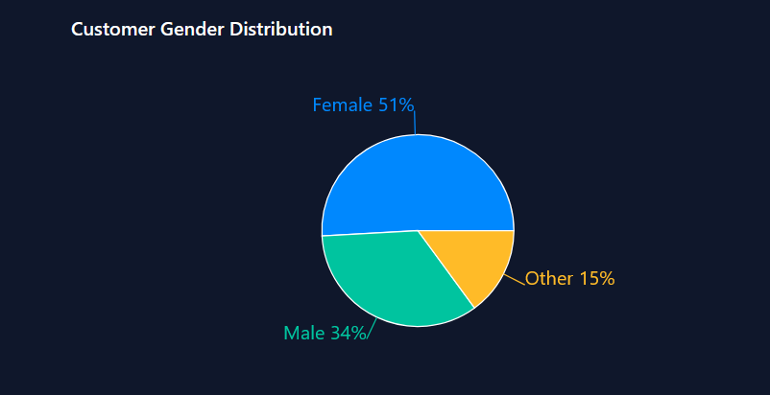Figure 3: Customer Gender Distribution.
Provides an overview of the proportion of male and female customers.
- Customer Region Distribution
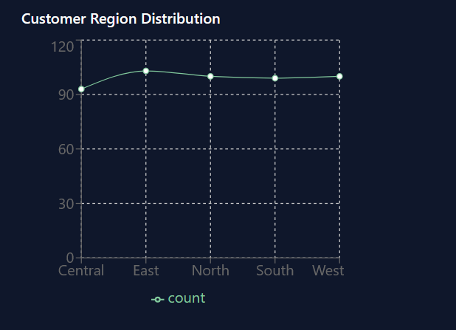
Figure 4: Customer Region Distribution.
Shows how customers are distributed across different regions.
- Loyalty Tier Distribution
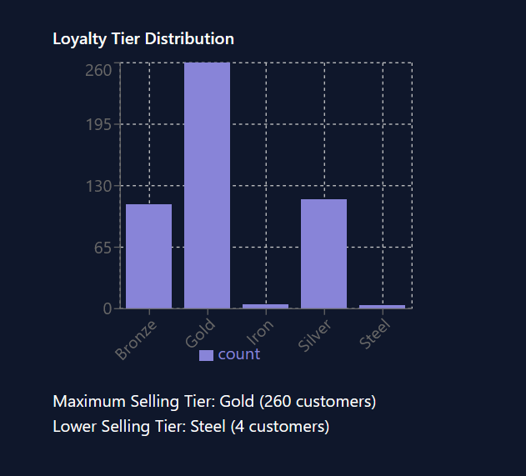
Figure 5: Loyalty Tier Distribution.
Illustrates the number of customers in each loyalty tier, helping to understand overall customer loyalty.

Conclusion:
The project successfully segmented customers using a combination of KMeans clustering and neural network modeling. The visualizations provide clear, actionable insights into customer demographics, regional distribution, and loyalty tiers. These insights can support better marketing strategies, customer engagement, and sales planning. Overall, the methodology ensures both accuracy and interpretability, making it a valuable tool for business decision-making.

